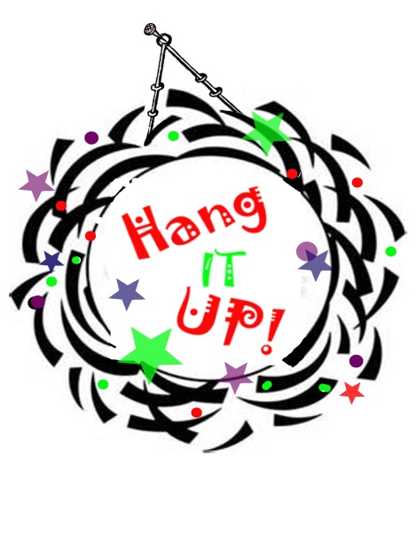
A Wreath Extravaganza!
Donate your creative inspiration to the
A.E. Backus Museum’s “Wreath Extravaganza”
.

- Open to EVERYONE – No Entry Fee - You need not be an “artiste” to enter
- Use your own wreath base or pick up a free one from the Museum- limited supply
- All Entries will be exhibited in the Gallery*
- Prizes in many categories, ribbons and bragging rights
- All wreaths will be donated, priced and sold by the Museum (your donation is tax-deductible) Wreaths will not be returned to their creators.
- *Limitations*: No perishable wreaths – your wreath should be usable year after year. No wreaths larger than 30” in diameter, no more than 25 pounds. All wreaths must be able to hang on the wall. Keep it family friendly.
Dates to Remember:
- Register and pick up your wreath base at the Museum September 23 – Nov. 15, 2014.
- Deliver completed wreaths to the Museum between November 15 – 23rd.
No wreaths accepted after 4 PM, Sunday, November 23rd.
- Wreath Extravaganza & Holiday Art Extravaganza Opens, Friday, Nov. 28, 2014
- Opening Reception and Holiday Open House – Friday, December 5, 5-8 PM
All wreath creators are invited to bring their friends to admire their inspired creations, listen to live music, sip a nip, eat a bite and shop for the holidays.
Prizes Will be Awarded in the Following Categories:
Traditional Holiday ● Recycled Materials ● Open ● Most Glamorous ● Most Original ●Funkiest ● Most Creative ●Sports ● Youth (under 18 years of age) ● School
Design Ideas: Truly, anything goes with this one. Why not create a wreath to represent a hobby like fishing, cooking, sewing or hunting. Sports Fan? - a Gators or Seminoles wreath would be fun! A wine or cigar themed wreath is unique? Try a wreath about the ocean or woods? 4th of July or Easter, don’t forget Hanukkah. You could use vintage hankies or silk neckties, leather or lace. Try Happy Meal toys or Beanie Babies. Silverware or china teacups! Corks, coins, buttons and bows could all be used. Take it to the limit. Let it all “hang” out! Most of all…….. just have fun with it.
CONTACT THE MUSEUM AT 772-465-0630, INFO@BACKUSMUSEUM.COM FOR MORE INFORMATION
A.E. BACKUS MUSEUM, 500 N INDIAN RIVER DRIVE, FORT PIERCE, FL 34950

